User Manual for OpenGL Recorder

## Overview

OpenGL Recorder is a demonstration C++/Java library. It has been integrated into the Minecraft source code as well as the light weight java game library (LWJGL) using JNI. This Manual is written by Farzon Lotfi. If you are unable to get this demo working please feel free to email [farzon@gatech.edu](mailto:farzon@gatech.edu) after 8/9/13 or [farzon.lotfi@intel.com](mailto:farzon.lotfi@intel.com) before.

## Recommended Settings

For best FPS performance turn Graphics to Fast, Render Distance to Tiny, Performance to Max FPS, Advanced OpenGL on, and Vsync off

## Interface

The interface for recording in Minecraft is simple. In the options panel is a button to turn Intel Media SDK on or off.

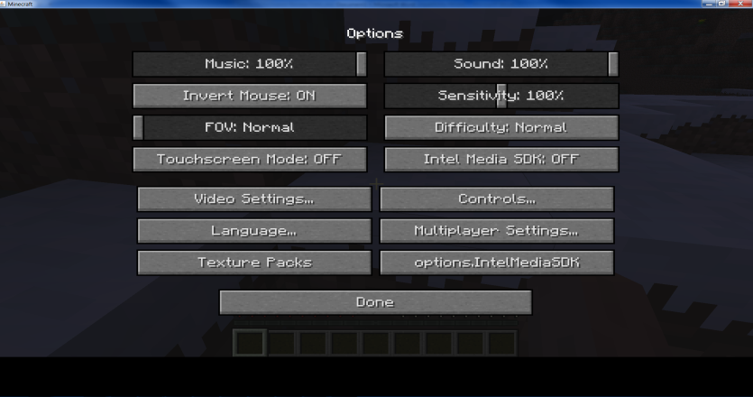

Screenshot - The user interface for Minecraft Record

This will give you the option to turn audio capture on or off and toggle software and hardware.

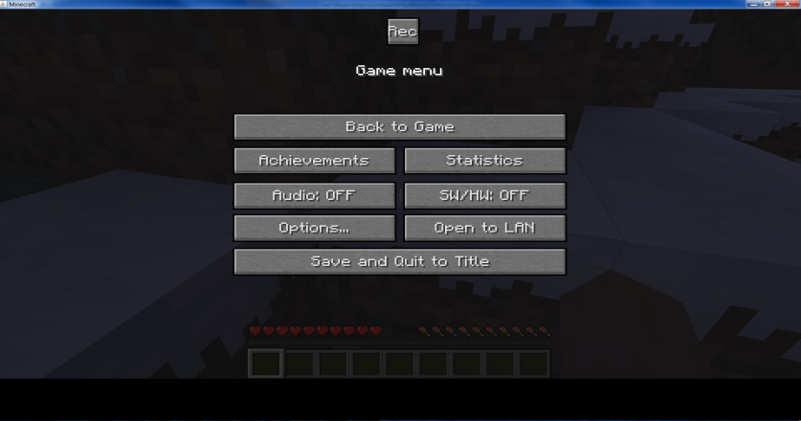

Screenshot – Enabled options

## Troubleshooting